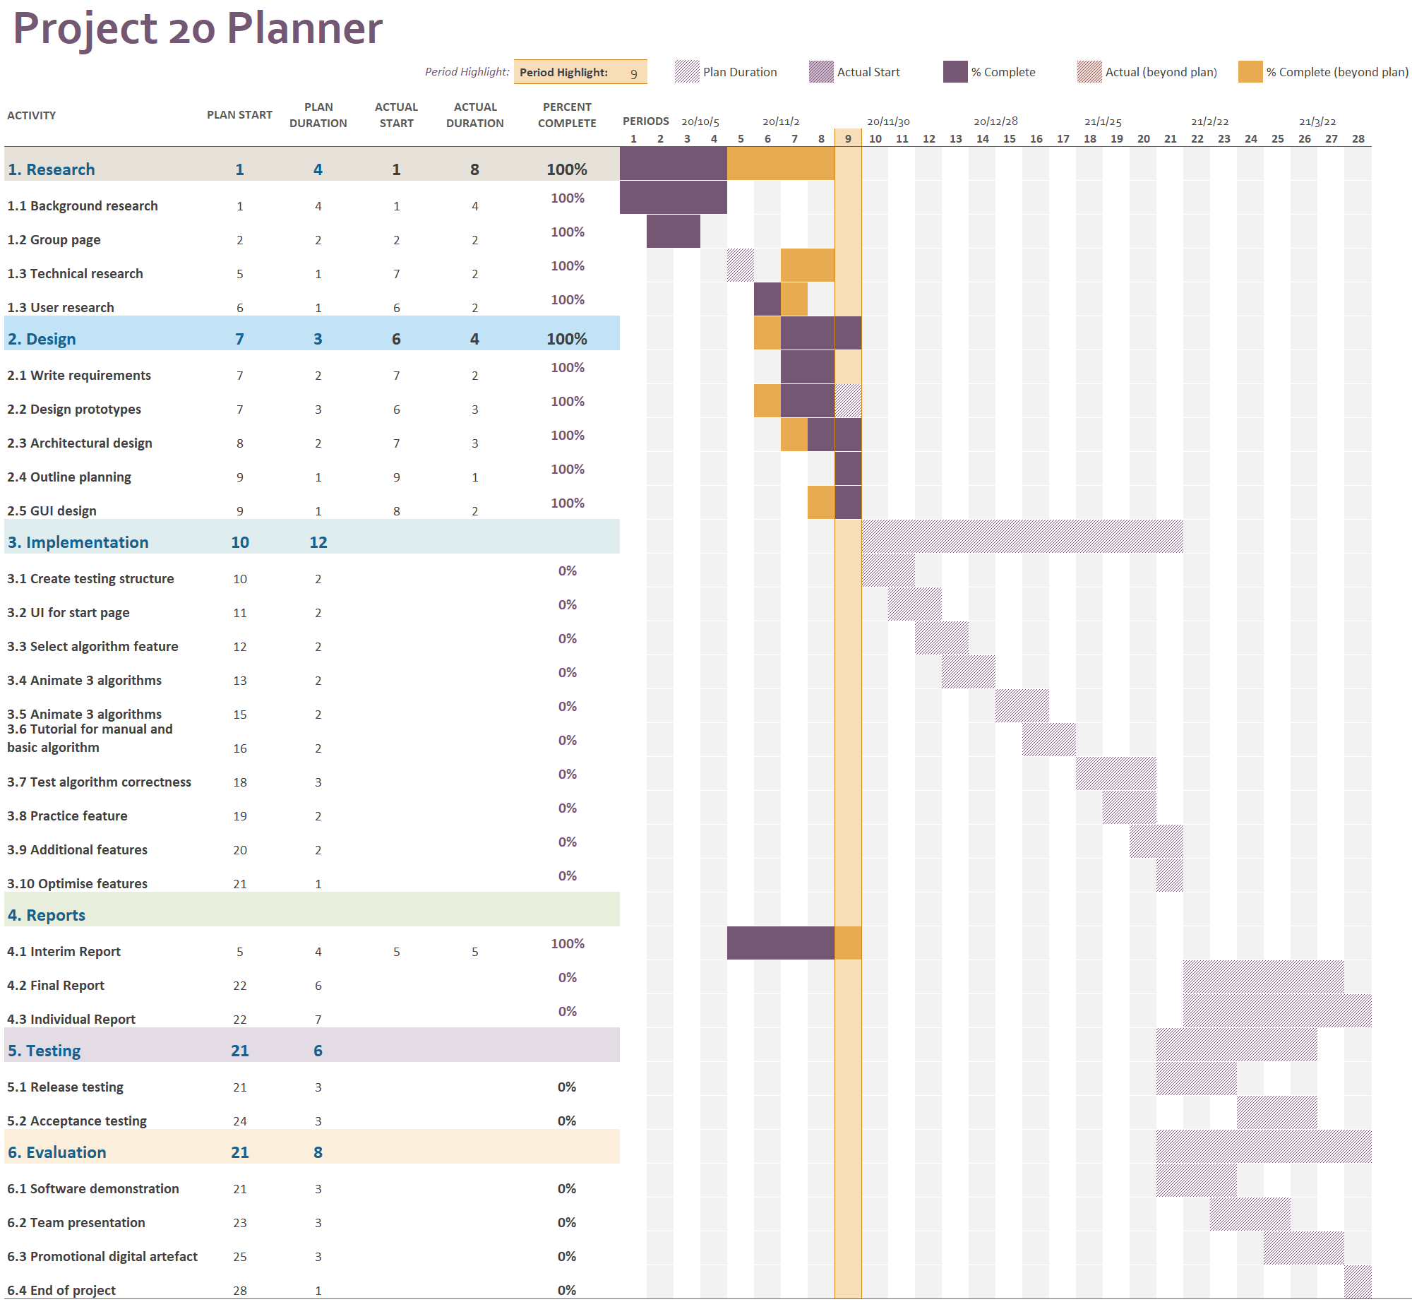

The timeline of the project is illustrated in a Gantt chart. The Gantt chart is made with Microsoft Excel. By typing in the start period and duration, the chart will show the bar of corresponding length automatically. The bars coloured with different colours denote different status. Team 10 utilises this tool to trace the current stage of the plan.

The plan is basically divided into six stages, research, design, implementation, reports, testing and evaluation. Except for reports stage, each of the stages is depended on the previous one. These stages are also presented in the Git project as milestones.